Untitled

Masumbuko Semba

November 19, 2018

setwd("E:/Data Manipulation/mafia_kilwa_octopus_mapping/CFMA shapefiles/")

files = dir(path = "E:/Data Manipulation/mafia_kilwa_octopus_mapping/CFMA shapefiles/", pattern = ".shp", include.dirs = TRUE, full.names = TRUE)

require(sf)

## Loading required package: sf

## Linking to GEOS 3.6.1, GDAL 2.2.3, PROJ 4.9.3

require(tidyverse)

## Loading required package: tidyverse

## -- Attaching packages ---------------------------------------------------------- tidyverse 1.2.1 --

## v ggplot2 3.1.0 v purrr 0.2.5  
## v tibble 1.4.2 v dplyr 0.7.8  
## v tidyr 0.8.2 v stringr 1.3.1  
## v readr 1.2.0 v forcats 0.3.0

## -- Conflicts ------------------------------------------------------------- tidyverse_conflicts() --  
## x dplyr::filter() masks stats::filter()  
## x dplyr::lag() masks stats::lag()

# for (i in 1:length(files)){  
   
   
 wwf = st_read(files[15])  
  
ggplot() +   
 geom_sf(data = wwf, fill = "red", col =1, alpha = 0.25)  
# }

## Data Sources, Processing and Analysis

# load Packages we need for data manipulation and analysis  
require(sf)  
require(ncdf4)  
# require(R.matlab)  
require(pracma)  
# require(cowplot)  
require(tidyverse)  
require(ggsn)  
require(insol)  
# require(RColorBrewer)  
require(lubridate)  
require(forecast)  
# require(ggpubr)  
require(akima)  
require(fields)  
require(maptools)  
require(marmap)  
require(oce)  
require(ggsci)  
# require(mapview)  
# require(mapedit)  
require(tmap)  
  
# # clear the worksapce  
# clear()

# read etopo 1 ascii file  
etopo = read.asciigrid("E:/GIS/ROADMAP/Etopo 1/Tanzania_etopo1/tanz1_-3432.asc")  
# convert the etopo file into tibble  
etopo.df = as.data.frame(etopo)%>%as.tibble()  
  
# tidy the data  
etopo.df = etopo.df%>%  
 rename(lon = s1,lat = s2, bathmetry = E..GIS.ROADMAP.Etopo.1.Tanzania_etopo1.tanz1_.3432.asc)%>%  
 select(lon,lat, bathmetry)  
  
# select the bathmetry value only within the pemba channel area of interest  
bathmetry = etopo.df%>%filter(lon>=39 & lon <=41 & lat >=-11 & lat <= -7 & bathmetry <=0)

You can spot a difference between a map generated with chunk code without being polished (figure 1) and the polished one in adobe illustrator (Figure 2)

ggplot() +   
 geom_raster(data = bathmetry %>% filter(bathmetry > -40 & bathmetry <5),   
 aes(x = lon, y = lat, fill = bathmetry), interpolate = TRUE)+  
 geom_sf(data = tz.ke, fill = "grey70", col = 1)+  
 coord_sf(ylim = c(-8.3,-7.5), xlim = c(39.25,39.9))+  
 geom_contour(data = bathmetry %>% filter(bathmetry > -40 & bathmetry <5),   
 aes(x = lon, y = lat, z = bathmetry), breaks = seq(-40, 0, 4), col = "grey50")+  
 geom_contour(data = bathmetry %>% filter(bathmetry > -40 & bathmetry <5),   
 aes(x = lon, y = lat, z = bathmetry), breaks = seq(-40, 0, 5), col = 1)+  
 theme_bw()+  
 theme(panel.background = element_rect(colour = 1, fill = "grey90"),  
 panel.grid = element_line(colour = "grey70"),  
 legend.direction = "horizontal",  
 legend.position = c(.85,.06),  
 legend.background = element_rect(colour = 1, fill = "grey85"),  
 axis.text = element_text(size = 10, colour = "grey30"))+  
 scale_fill_gradientn(colours = oceColorsGebco(120), name = "",   
 breaks = seq(-35,-5,10),  
 label = seq(35,5,-10))+  
 scale_x_continuous(breaks = seq(39.3,40, length.out = 5) %>% round(digits = 2))+  
 labs(x = NULL, y = NULL)

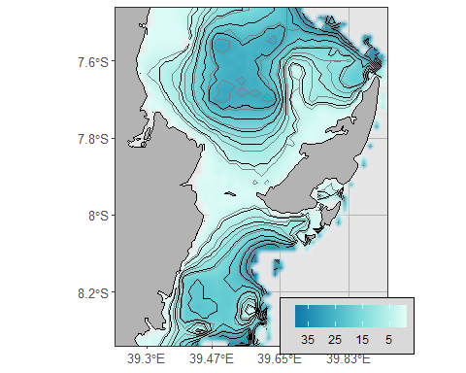

Figure 1 original map made with ggplot

# ggsave("fig 1.pdf")  
# ggsave("fig 1.eps")

knitr::include_graphics("fig 1.png")

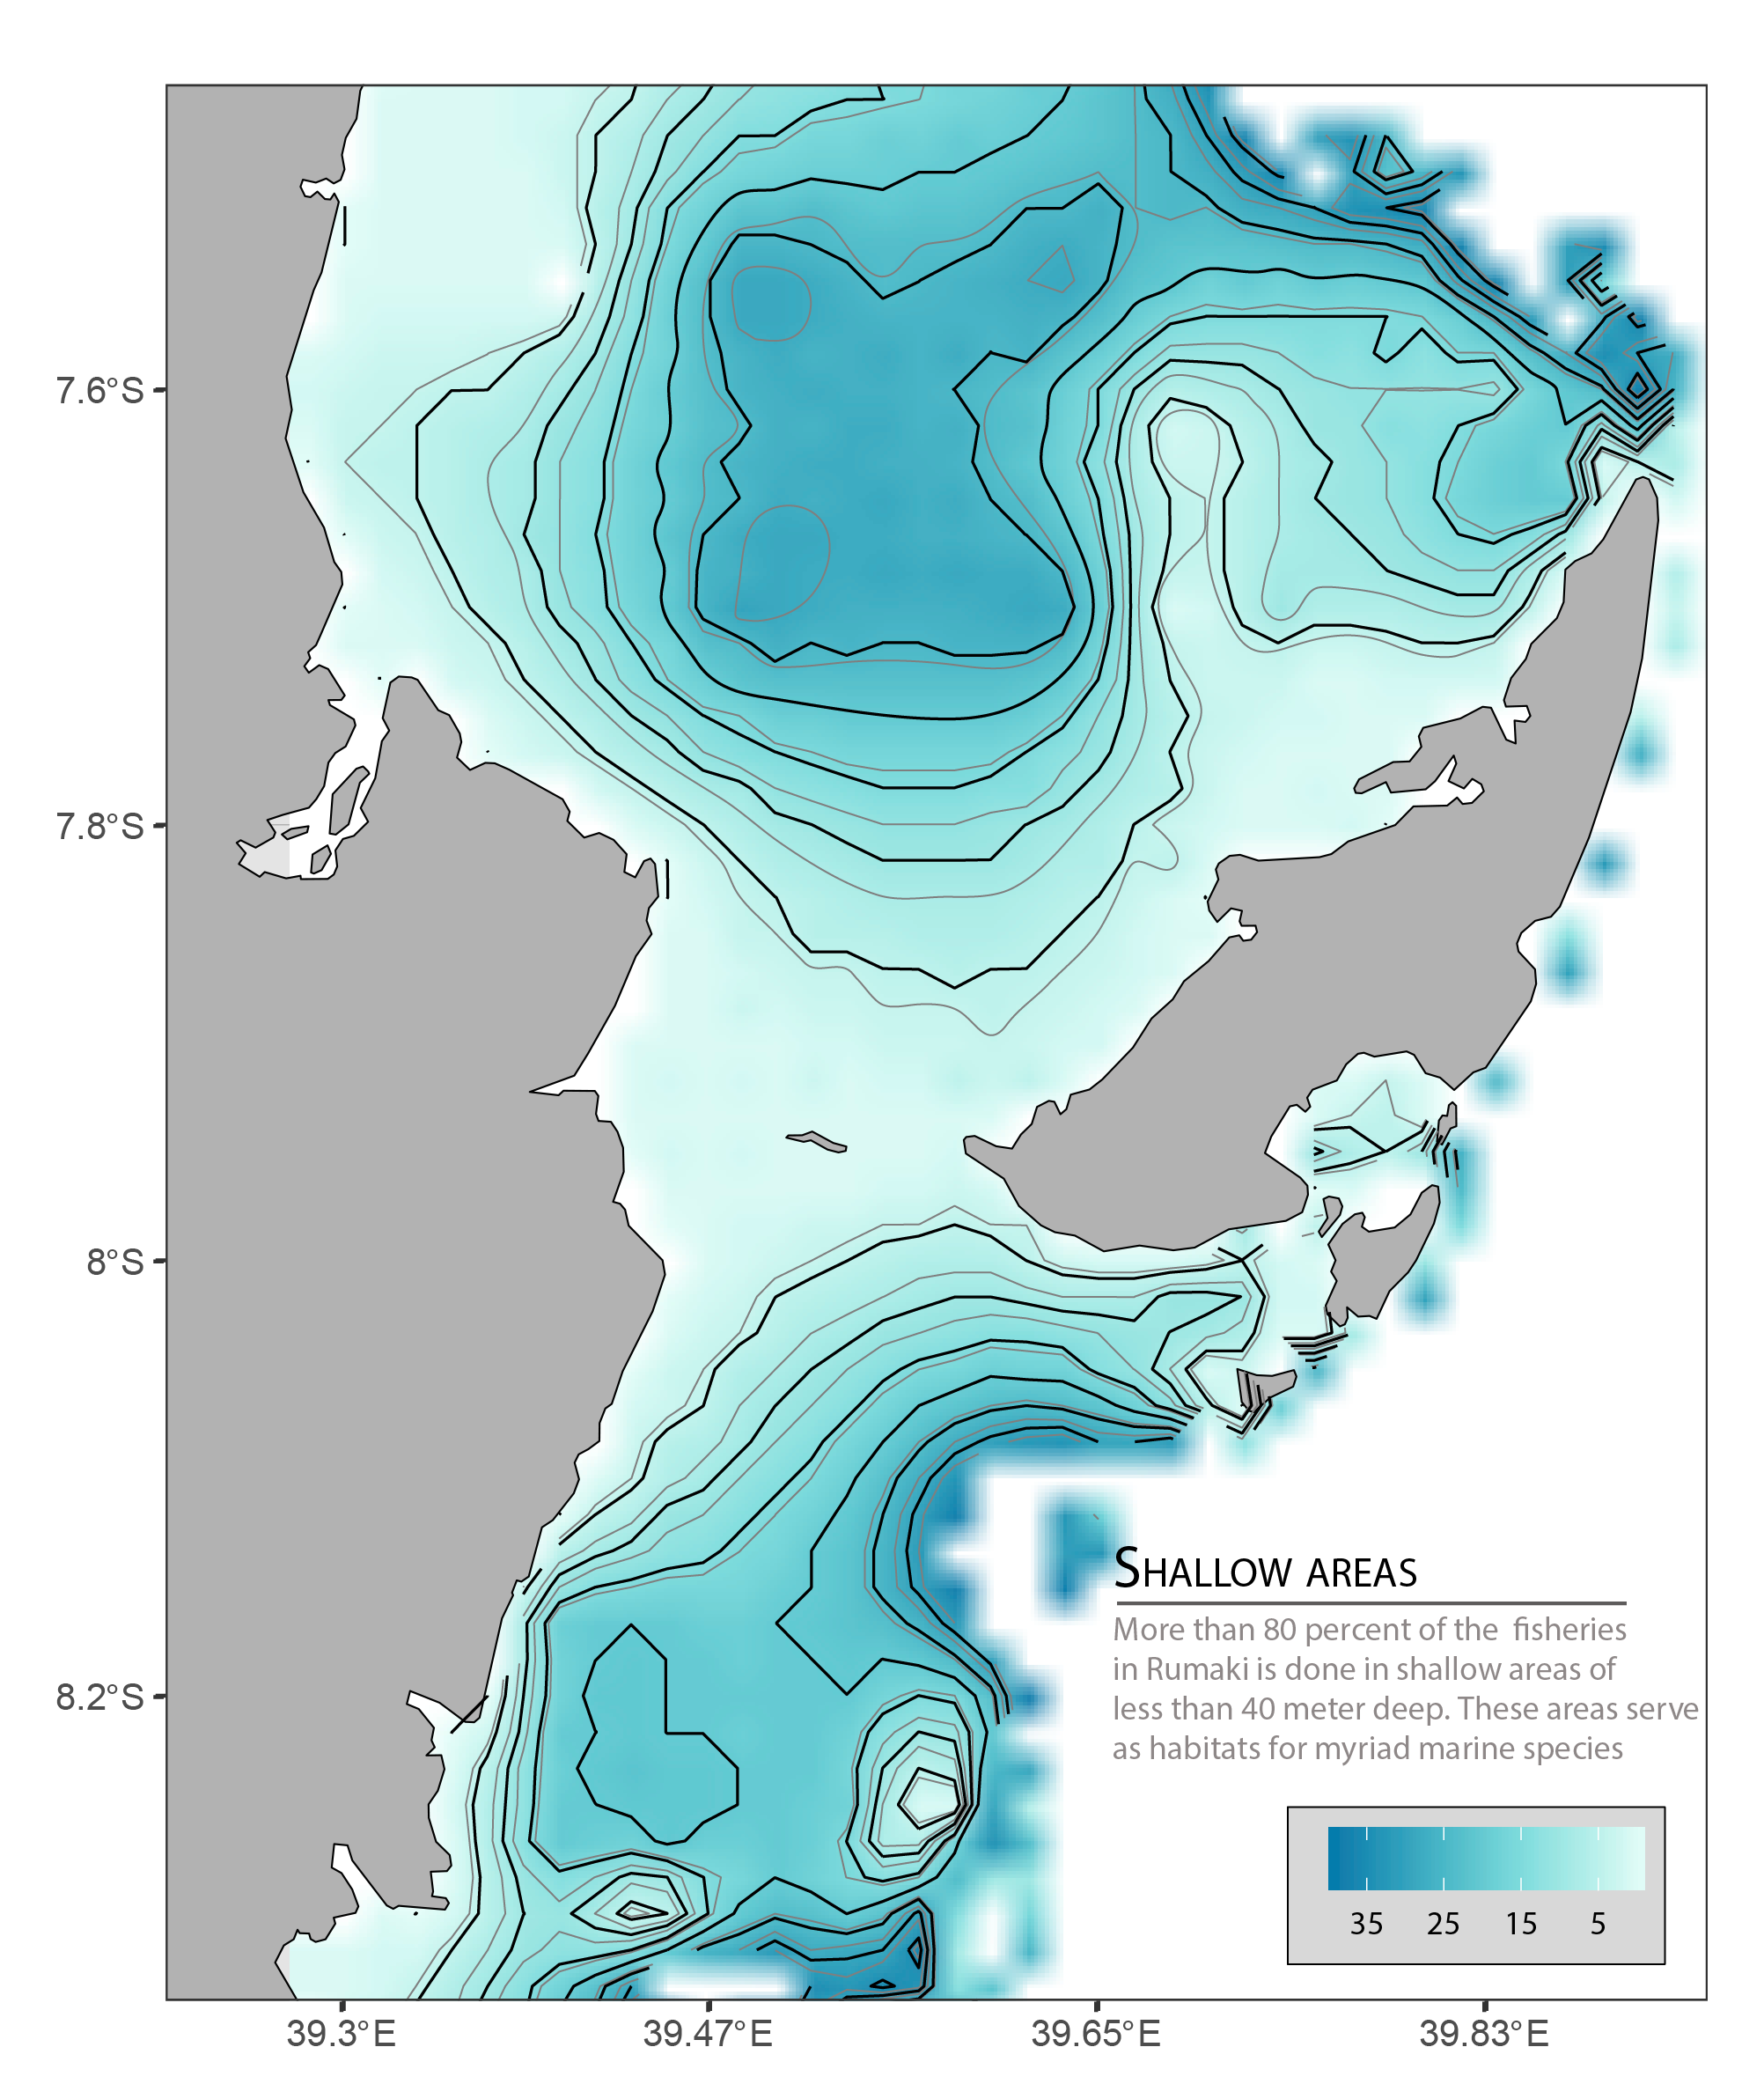

Figure 2 Edited figure in illustrator

# cowplot::draw_image("fig 1.png")